Develop Your Personal Brand (for General Purpose)
Version:1
Published: May 13, 2025

**********FAC NOTE **********
Desired Learning Outcomes: Learner should define their personal brand and create a Personal Statement that can be added to their Workday Profile.

Class Handouts: Activity Guide, (Reflective Guide is optional)

There is 1 Poll Question. The group reflects on the answers to the poll at the end of the course.
Poll #1:
“When you think about your personal brand, which statement best describes how you feel?”
- I have a clear understanding of my personal brand and actively manage it.
- I have some idea of what my personal brand is, but I’m not sure how to develop it further.
- I’ve never really thought about having a personal brand before.
- I find the concept of a personal brand confusing or intimidating.
- I have no need for a personal brand.

There are 3 video links:
Slide 17: https://youtu.be/MIA_1xQc7x8?si=pBnuHqaxAfoUJDSl
Slide 24: https://tmobileusa.sharepoint.com/sites/tn-hr/Applying as an Internal/Update Your Career Profile.mp4
Slide 27: https://share.percipio.com/cd/VY9EGjCGI

There are 2 activity blocks: There are 2 spaces in the deck for activities to take place.
- First Block: There are 3 possible activities, including 1 for leaders.
- Second Block: Participants create a Workday Profile Statement

Important: You can select the specific activities you want to run based on your audience and client needs. Activities are designed to be flexible – allowing you to shorten or lengthen the duration as needed. They can also be done individually as solo work, or with partners or within teams. Use a configuration that best works for your situation.

1 | 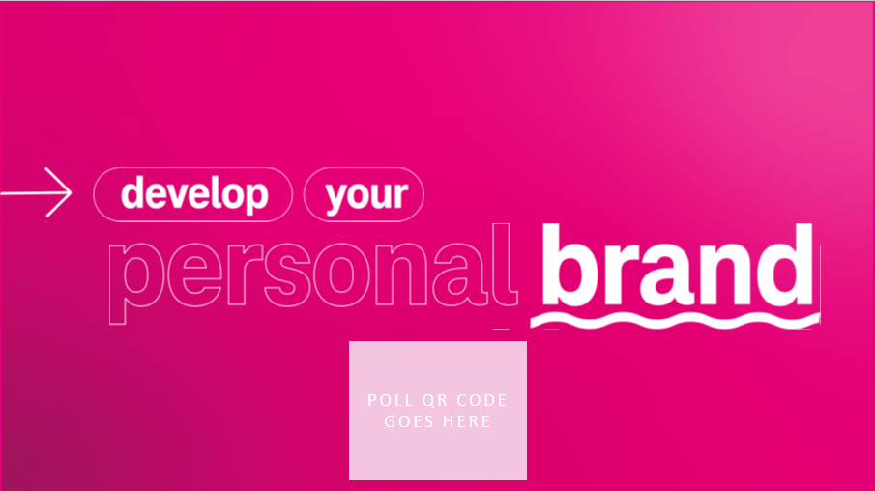 | SAY: Welcome to “Developing Your Personal Brand” !  While we are waiting to get started, please take our poll.
2 | 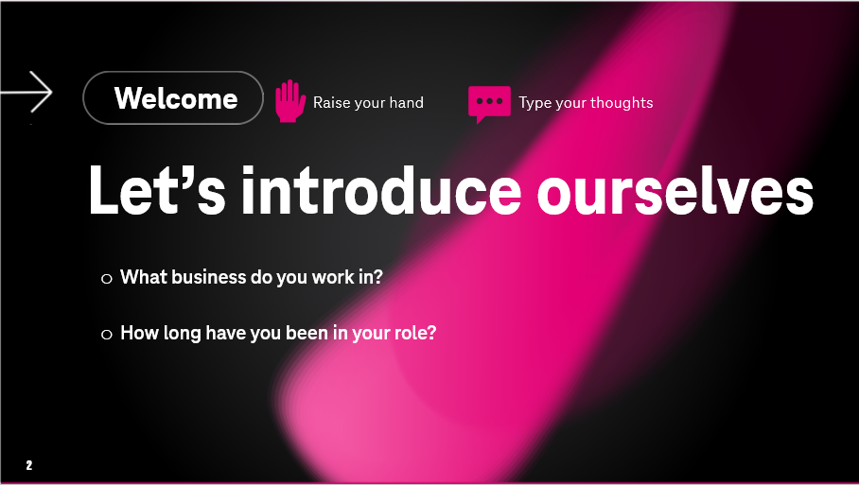 | SAY: Thank you for responding to the poll question. We’ll talk about the results of our poll in a few minutes.  Before we do, I’d like to take a few minutes for introductions.  [ACTION]  If 1−8 participants:  Introduce yourself and ask others to follow. Participants should share:  - Name  - Worksite  - Tenure  - LOB  If 9−20 participants:  Have participants introduce themselves to one another by typing in the chat.  (Feel free to modify what you’d like to know about them.)
3 | 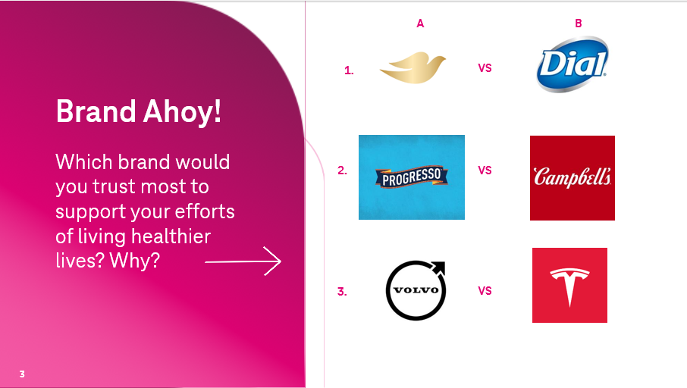 | Say: Let’s start with a little game —brand identity style. Here are three categories of brands. Number 1 includes 2 different brands of soap. Number 2 has different brands of soup. And number 3 are different brands of cars.  I need three volunteers to provide their insights into these brands.  ASK:  Who would like to volunteer?  SAY:  OK – for our first volunteer:  ASK:  On question 1, If you wanted to support your efforts of living a healthier lifestyle, which one of these brands would you pick? column A or column B? What information did you use to inform your choice?  <pause for response>  ASK:  What information did you use to inform your choice?  <pause for response>  SAY:  Now onto our next volunteer:  ASK:  On question 2, If you wanted to support your efforts of living a healthier lifestyle, which one of these brands would you pick? column A or column B?  <pause for response>  ASK:  Why did you select that answer?  <pause for response>  SAY:  OK for our last volunteer:  ASK:  On question 3, If you wanted to support your efforts of living a healthier lifestyle, which one of these brands would you pick? column A or column B? Why did you select that answer?  <pause for response>  ASK:  Why did you select that answer?  <pause for response>  SAY:  Great work everyone. This was a fun way to recognize that brands can be complex and inform our feelings about them in objective and subjective ways. Think back to the reasons our volunteers gave for their selections.  <pause for response>  ASK:  Did they include objective information like facts and figures?  <pause for response>  ASK:  Did they include subjective information based on emotions, feelings?  <pause for response>  SAY:  These are just some of the reasons why brands can be so important.  We form an opinion of a brand to the point where it influences our thinking and decision making - even though we may not have had first-hand experience with the product itself.  As you’ll see in this course, the same is true of Personal Brands.
4 | 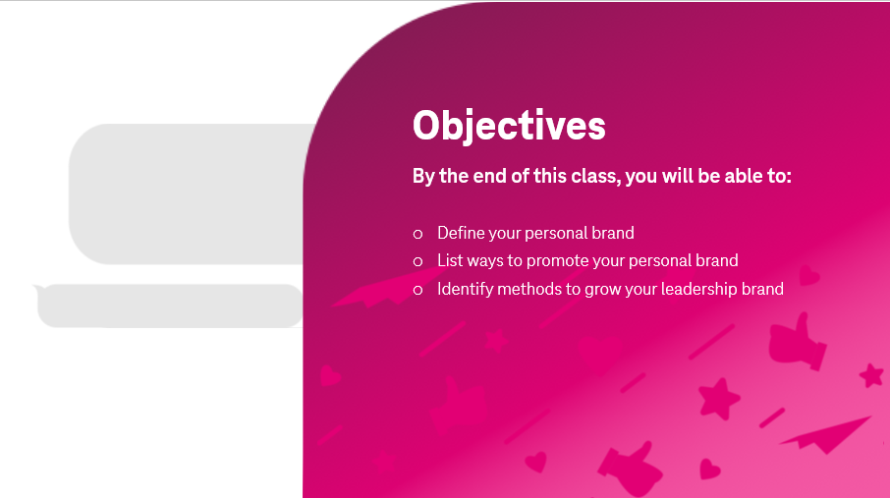 | SAY: Our objectives during our time together today is for each of you to be able to:  - Define your personal brand  - Describe your personal statement  - Identify ways to grow and maintain your brand
5 | 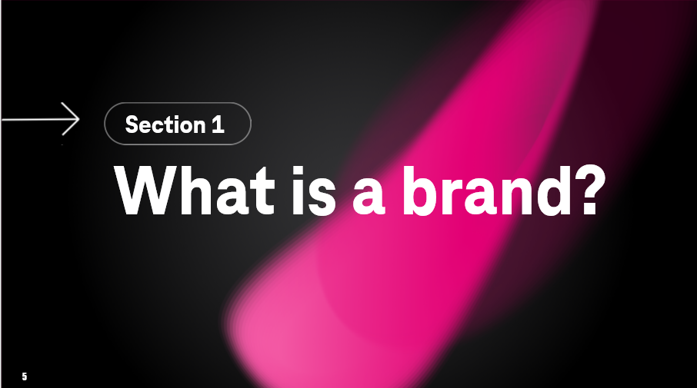 | Say: So, what exactly is a personal brand? Quite simply—it’s you!  Now the more complex question is – who exactly are you?
6 | 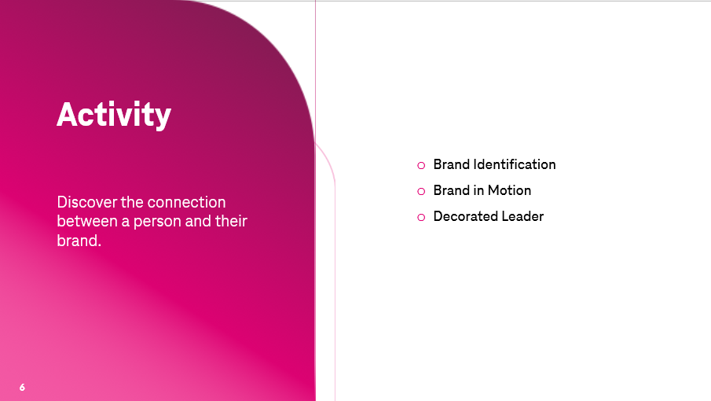 | **FAC NOTE: ***  Select Activity for participants to complete. The activities can be done individually in solo mode, or with a partner or within a team. Each activity takes about 7 minutes to complete.  Activity: Brand Identification – Participants identify someone that demonstrates a strong brand and answers questions about brand PERCEPTION.  Activity: Brand in Motion – Participants identify someone that demonstrates a strong brand and answers questions about brand ACTIONS.  (Leader)Activity: Decorated Leader – Participants identify a) Attribute / Value and b) Action / Function of each part of a “Gingerbread Leader”  SAY:  Let’s do an activity that helps you make the connection between a person and their brand  **FAC: Distribute the Activity Guide and review your selected activity. If needed, place participants into groups, breakout rooms, etc.
7 | 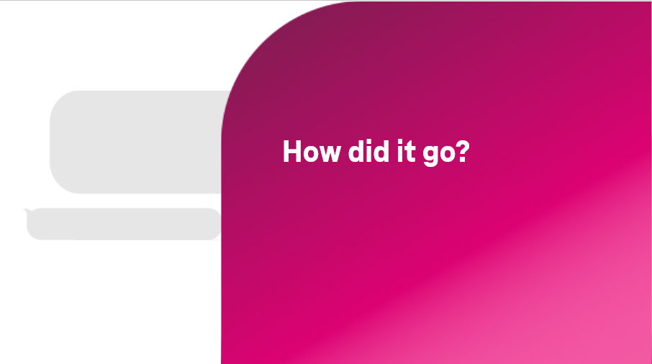 | SAY:  Welcome back!  ASK:  So how did it go? <pause for participants>  ASK:  Who wants to volunteer sharing their insights from the activity?  <pause for participants>  **FAC NOTE:  Use the following questions (below) from the activity guide if needed. Some key aspects to call attention to during the report out include:  Is personal brand shaped by people’s perception or actual facts or both?  Do participants have a good understanding of how others perceive them? If so, is it accurate? How can they improve or correct other people’s perception?  Activity #1:  - Was your opinion of the person formed from Objective information or Subjective information?  - Did their brand make them stand-out amongst their peers?  Activity #2:  - Did the actions of the person with the strong brand fall into the extremes, such as NEVER some things, and ALWAYS doing others? Or was there more of a mix that included things done seldomly or often?  - Did you find that there were patterns or commonality with the actions they ALWAYS did or things that they NEVER did?  Activity #3:  - How did you go about matching a value with an action for the parts of your Gingerbread leader?  - How did your Gingerbread leader demonstrate one of the Values in Action?  - What does it mean to have leadership as part of your personal brand?  - Which part of the Gingerbread leader was most inclusive when collaborating?  - Does your Gingerbread leader function more strategically or more reactionary to the events unfolding around them?  - How does your Gingerbread leader communicate?
8 | 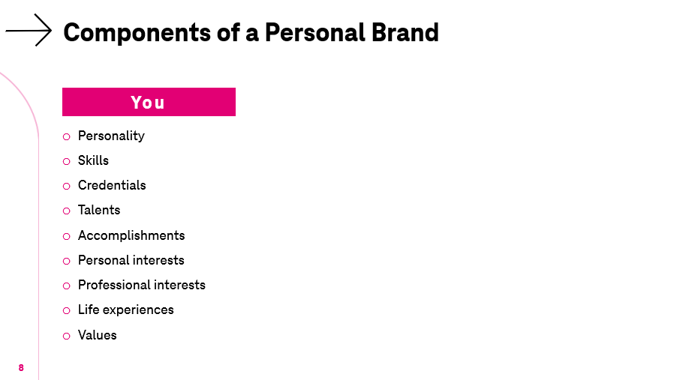 | SAY: Now that we have seen how a person and their brand are connected, let’s look closer at some of the items that form a personal brand.  These first items relate to who you are as a person, because nobody else is exactly like you. We will call this category “You”, and inside your category are items such as your personality, skills, credentials, interests, experiences and values.  ASK:  Do you notice anything missing from this list?  <pause for response>  [PROMPT: Does the list reference job title, role, or rank within T-Mobile?]  <pause for response>  SAY:  Correct. We have intentionally left out “what” you do.
9 | 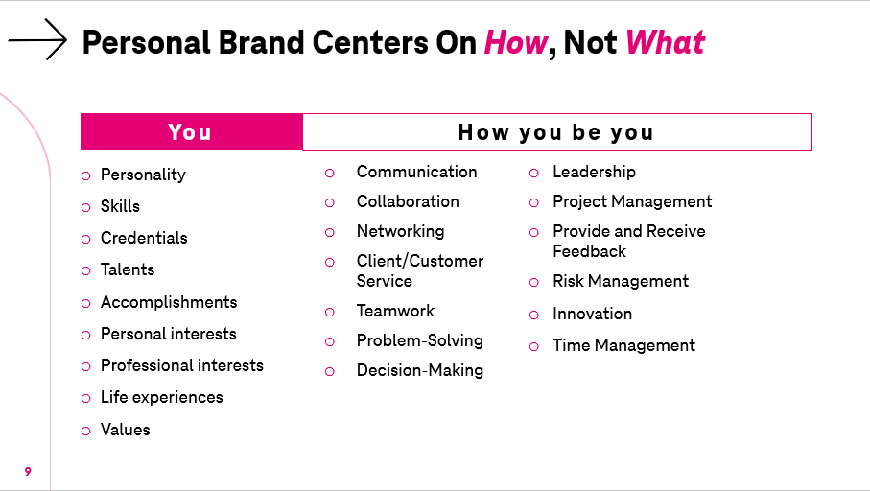 | Say:  Instead, we are focusing on “how you do it”.  So we’re not including job titles or job tasks that are normally part of our work. Why? Because personal brand is not based on ‘what’ you do - it’s based on ‘how’ you do it.  Your work is important of course. But when it comes to your brand, the way you do your work is more important than the work you do.  We can put this to a simple test:  ASK:  Is a personal brand reserved solely for senior leaders?  <pause for response>  Say:  No. Of course not. Everyone needs a personal brand, no matter what their role is. At the end of the day, personal branding is how you present yourself to the world, regardless of what you are doing. We encourage you to embrace your talents, values, and beliefs, as they shape your decisions, actions, and professional identity.
10 | 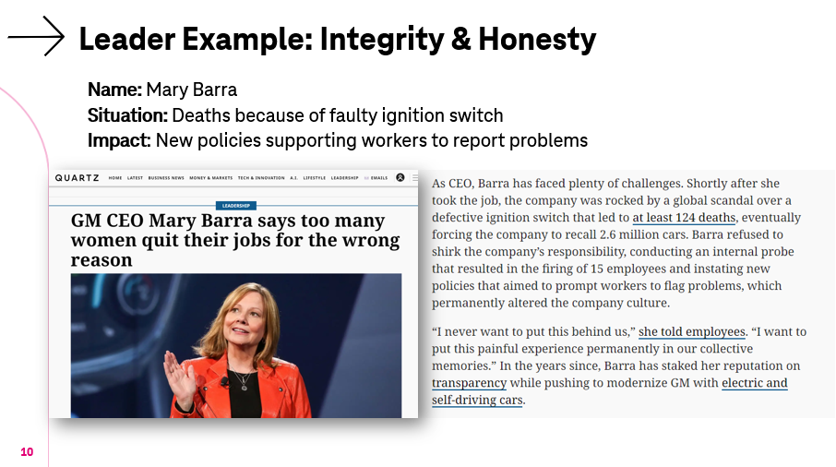 | SAY:  Think back to the activity, you’ve already had a chance to see at least one example of how a person forms their brand using aspects of who they are – combined with how they do their work and live their lives.  Now we are going to see some other examples. These people may be unfamiliar to you, since you probably have not worked with them – and – they are not huge popular culture figures. While you learn about these examples, look for the ways they connect their values with their actions.  First up is Mary Barra, CEO of General Motors. At the start of her tenure as CEO of GM, she had to deal with a major safety issue: ignition switches in GM cars were shutting off the engine while the car was in motion. This not only caused accidents, but having the ignition switch off also meant airbags would not deploy. 124 people died because of this error in engineering and the investigation revealed - it was not a one-time mistake. It turns out, the ignition switch issue had been known for 10 years – but a culture of silence within GM prevented any action on the issue.  Mary Barra demonstrated integrity and honesty in her leadership by taking responsibility and making sweeping changes to the organization, including:  - Forming internal safety teams that report directly to senior leadership and the board  - Starting an employee “Speak Up For Safety” program – empowering all employees to report safety issues  - Implemented new onboarding and new hire orientation programs to rebuild a culture of safety
11 | 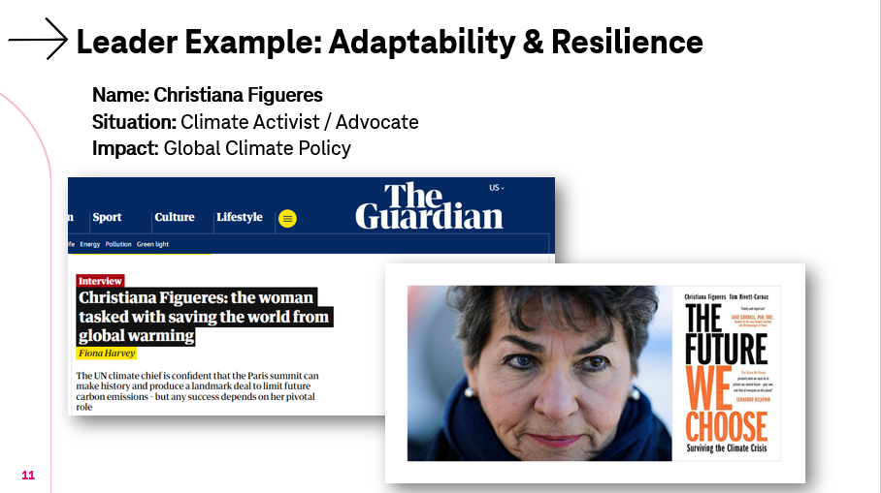 | SAY:  Here is another example. Christiana Figueres ( pronounced “few-gare-ezz” ) is a diplomat from Costa Rica that has demonstrating an ability to adapt and pivot in a relentless campaign on climate change. As you can imagine, working on climate change takes a degree of tenacity and commitment to the cause. Having worked through considerable setbacks on the global stage, she became one of the key architects of the Paris Agreement on climate change, bringing together 195 countries to adopt that first of its kind global policy.  **FAC Note: video is on next slide
12 | 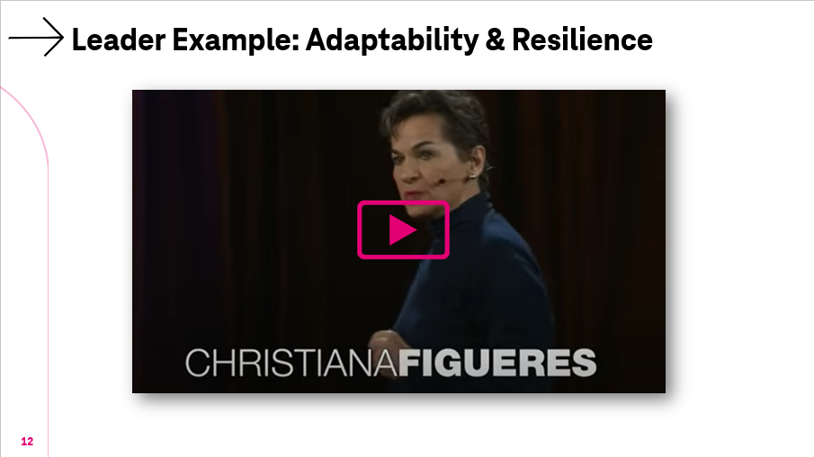 | SAY:  Let’s watch a short clip to gain a better understanding of Christiana Figueres’s brand.  ** FAC: Play video until 5:20 mark where she says ”….and believe you me, there has been a lot of contrary evidence.”  You Tube:  https://youtu.be/MIA_1xQc7x8?si=pBnuHqaxAfoUJDSl
13 | 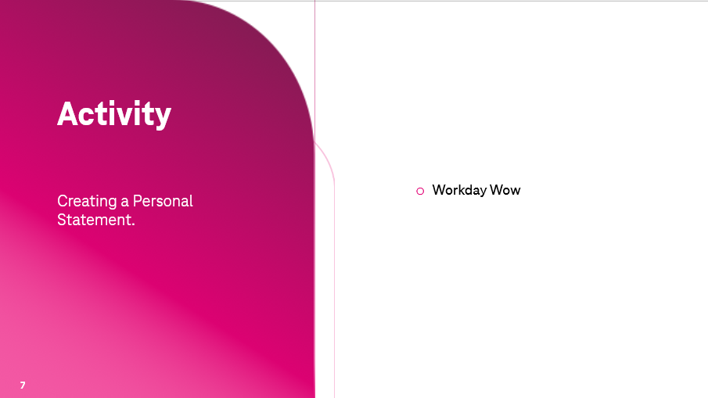 | **FAC NOTE: ***  Select Activity “Workday Wow” for participants to complete. The activity can be done individually in solo mode, or with a partner or within a team. The activity takes roughly 15 to 20 minutes.  Activity: Workday Wow! – Participants create their personal statement for their Workday Profile  SAY:  Those were some inspirational examples. While it’s true that we may not get a chance to make such a large impact as our examples, we can – and do, make meaningful impacts each and every day. That’s why our next activity involves writing a Personal Statement for your Workday profile. The personal statement will bring your brand to the surface – representing and promoting you, your values, and your actions to all of T-Mobile.  Many of you may know this already – but to make sure everyone is aware – your information in Workday is used in many ways – by many people.  For example:  - People reviewing org charts  - People looking for specific skills or experiences  - People that heard great things about you and want to learn more  - People looking for mentors  - People seeking collaborators  I can keep going, but you get a sense what I mean.  So, with that said, let’s dive into the activity!  **FAC: Distribute the Activity “Workday Wow” and review with learners. If needed, place participants into groups, breakout rooms, etc.
14 | 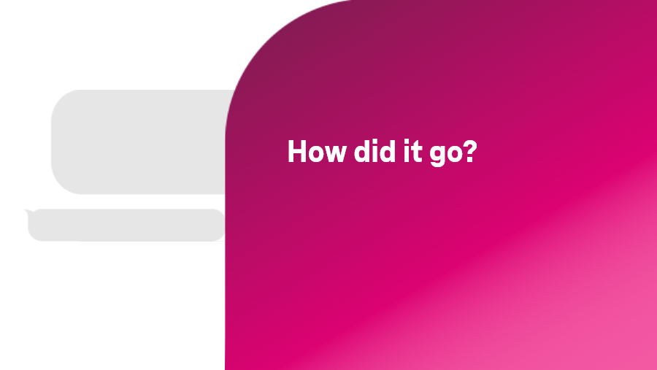 | SAY:  Welcome back!  ASK:  So how did it go?  <pause for participants>  ASK:  Who wants to volunteer to share what they came up with for their profile statement?  <pause for participants>  *** FAC Notes: Debrief as you think best. Options could include:  a) Having everyone share their profile statement  b) Asking questions about the process, such as the challenge of combining values with actions to become a statement  c) Asking if they needed more resources about how their brand was perceived.  d) Asking if some people did not complete the statement – or if they think they want to revise it after they think about it some more
15 | 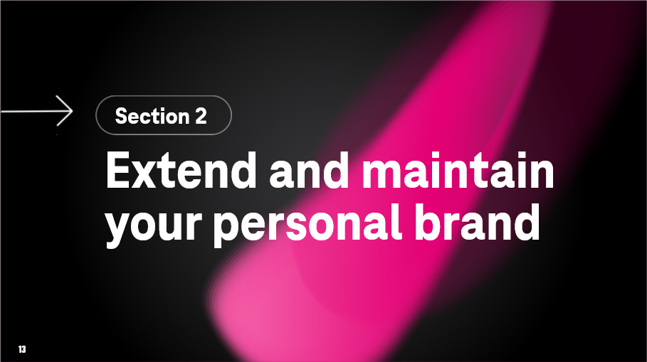 | Say:  OK - We’re now ready for Section 2, which will focus on extending and maintaining your personal brand.
16 | 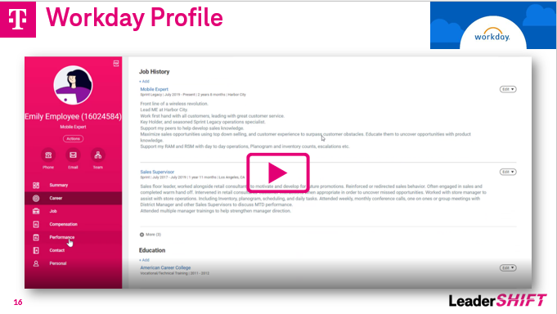 | Say:  As mentioned, getting your profile statement into Workday is an essential way to increase the presence of your personal brand. It’s also important to call out that you can benefit greatly by completing other information in your profile, such as:  - Skills  - Projects  - Credentials / Certificates  - Awards and Recognition  Here’s a quick video that shows how it works in Workday. Instructions are also available on Workday.  [PLAY VIDEO] https://tmobileusa.sharepoint.com/sites/tn-hr/Applying as an Internal/Update Your Career Profile.mp4
17 | 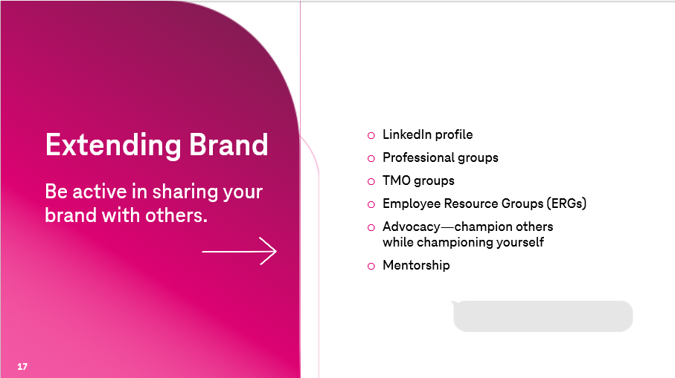 | Say: You can leverage the power of professional resources such as LinkedIn, which allows you to build a profile with similar sections as your Workday profile.  You can also expand that profile by including connections to outside organizations, such as groups you may volunteer with or professional organizations you may be a part of or causes and initiatives you support.  Extending brand awareness can be accomplished in a variety of ways inside and outside of T-Mobile. For instance, our work environment supports a variety of workgroups centered around specific technology, products, marketing, user experiences, neighborhoods, hobbies, sports, and volunteering.  A particularly dynamic way to promote yourself is through our many Employee Resource Groups.  ASK:  Is anyone in the class today part of an Employee Resource Group?  <pause for response>  ASK:  Have you found that it’s a positive environment to show and promote your personal brand?  <pause for response>  Of course, you are not restricted to just groups within T-Mobile. There are many such groups in your own local community that you can access, contribute, and participate with.  ASK:  Are there any questions around what promoting your brand might look like?  <pause for response>
18 | 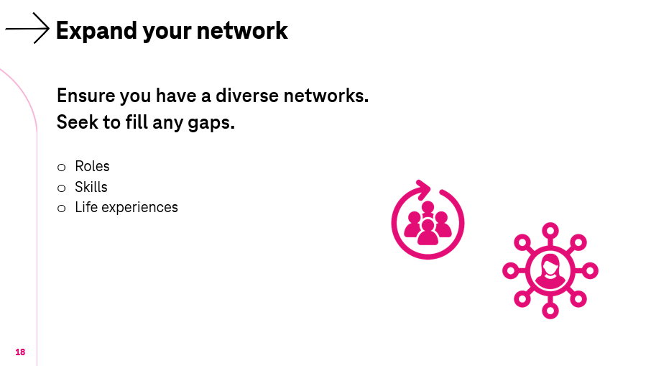 | Say:  Consider ways to expand your network by joining T-Mobile groups or volunteering.  While many people have an existing network around them that is supportive and resourceful, it most likely can benefit by expanding it with the intent of filling in some important gaps. In fact, we may not even know we have gaps.  We are all impacted by having a bias.  There are two of them in particular that play a role in expanding our network:  * Confirmation Bias – Humans have a tendency to want to see and hear things that confirm their view of the world – be it politics, music, religion, food, etc. As a result, we tend to avoid people and situations that are different.  * Unconscious Bias – These are blind spots that allow us to believe that we have a diverse and robust network.  Here are some questions you can ask yourself if you need to check up on your unconscious bias.  Can you identify someone in your network that:  - Has a different political viewpoint than you?  - Has a significantly different cultural background than you?  - Is in a significantly different tax bracket than you?  If people in your network don’t come to mind when you ask yourself these questions, there may be opportunity for you to expand your network in meaningful ways.  Because if everyone in your network has the same type of strengths and experiences as you, you’ll be missing a great opportunity to learn directly from others.
19 | 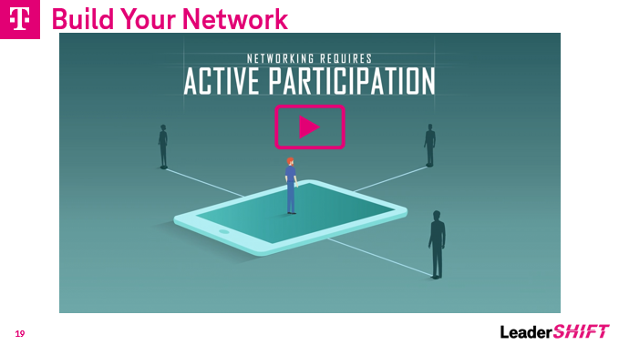 | Say: Here is a short video that looks at five steps to building and sustaining these important relationships.  [PLAY VIDEO] https://share.percipio.com/cd/VY9EGjCGI
20 | 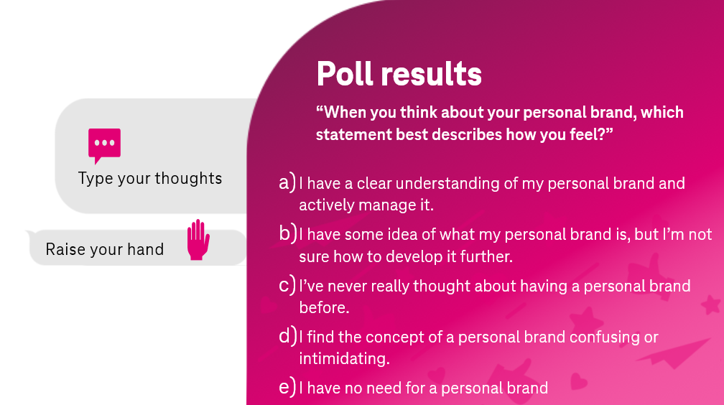 | SAY:  Now, as we come to an end of our time together today, lets end where we began. Let’s look at how you answered the poll question when we started this class.  When asked about your personal brand, you could choose one of these statement that best describes how you feel:  - I have a clear understanding of my personal brand and actively manage it.  - I have some idea of what my personal brand is, but I’m not sure how to develop it further.  - I’ve never really thought about having a personal brand before.  - I find the concept of a personal brand confusing or intimidating.  - I have no need for a personal brand.  SAY:  Think back to the answer you gave and ask yourself if you would answer any differently after our time together today.  ASK:  Raise your hand or give a shout out if your answer has changed.  Who would like to share how their answer changed and why?  <Pause for participants>  **FAC: Continue this sharing as short or as long as you need. **
21 | 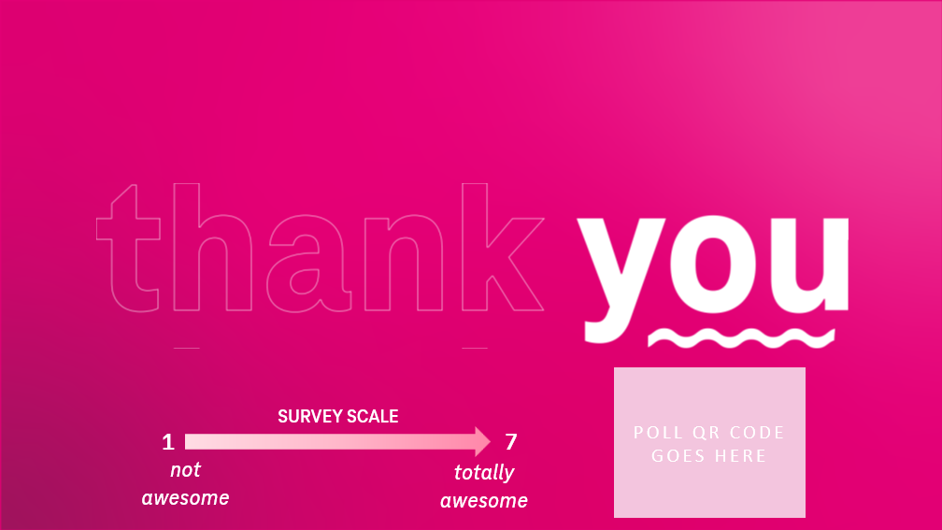 | Say: Those are all great insights! You all have been great today, and I appreciate the time, effort, and attention you gave to creating your Workday Profile Statement!  May your brand be with you!  Thank you!

