Version #7 published 11/24/25
TITLE: Course 101: Forming Your Foundation of ChatGPT
FACILITATOR NOTES: This is an introductory course that provides learners with basic navigation of the platform, as well as best practices for effective use of prompts. Please preload prompts into ChatGPT in case of errors during the live session. An index of the prompts is available to make it easier.
SPAN OF CONTENT: Login and basic navigation to using images as a chat input and overview of Canvas.
RESOURCES: Share the links through WebEx chat. Preferred method is to send the .zip link.
NAME | LINKS FOR LEARNERS
ALL FILES IN A .ZIP FOLDER | https://t-mobile.bravais.com/s/1494/ChatGPT_101_Class_Hand_Outs
INDIVIDUAL FILES IF NEEDED
File 1 (white board image) | https://tmobileusa-my.sharepoint.com/:i:/g/personal/craig_snyder42_t-mobile_com/EVQfC4yJVQhDnPOSUT3Ezw0B1rorAYFJxnjq1sYtfal5ig
File 2 (2021 Financials) | https://t-mobile.bravais.com/s/1396/File_2_ChatGPT_101
File 3 (2024 Financials) | https://t-mobile.bravais.com/s/1397/File_3_ChatGPT_101
File 4 ChatGPT 101 PROMPTS | https://t-mobile.bravais.com/s/1411/ChatGPT_101_PROMPTS
Activity Guide | https://t-mobile.bravais.com/s/1398/ChatGPT_101_Activity_Guide
Teams Channel | Enterprise GPT - General | Enterprise GPT - General Support | Microsoft Teams

IMPORTANT TO KNOW:
- Most of this course is a live demonstration that involves the facilitator entering prompts via copy/paste in real time as they narrate the script. Ensure you are saying the prompt numbers out loud so learners can follow along.
- Learners are encouraged to follow along with the activities – but it’s not required.
- A small portion of the prompts are used to provide visuals that reinforce the content – and not meant to be run by learners. However, they are listed in their Prompt Sheet as optional if they want to follow along.
- ChatGPT will load long responses to prompts, so please scroll and center the content to the center of the screen as needed in relation to what you are discussing in the moment.
- Prompts should be run in advance to pre-load them into navigation menu to reference if needed
 | TIME: 0-5 | 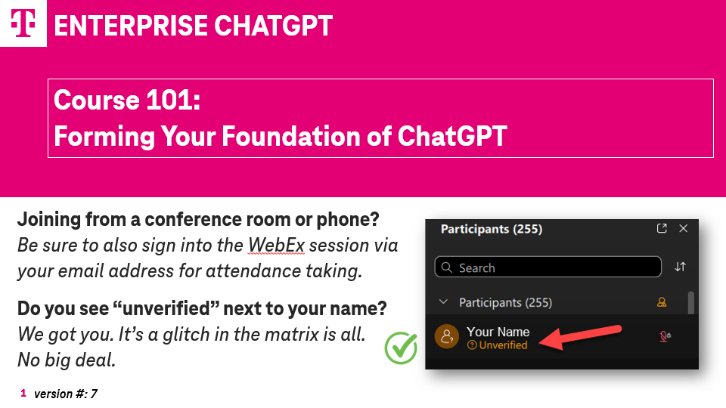 | SAY:  Welcome all! As we wait a few minutes for others to dial in – please know that if you are joining from a Conference Room or Phone, we need you to also sign-in via WebEx with your T-Mobile email address for attendance taking.  You only need to do that if you do not see your name listed in the Participant list.  If you see the word “Unverified” next to your name – don’t be alarmed – it’s just a glitch in the system. You do not have to do anything special for attendance. We got you!
 | ACTION  Course duration to this point:  5 min. | 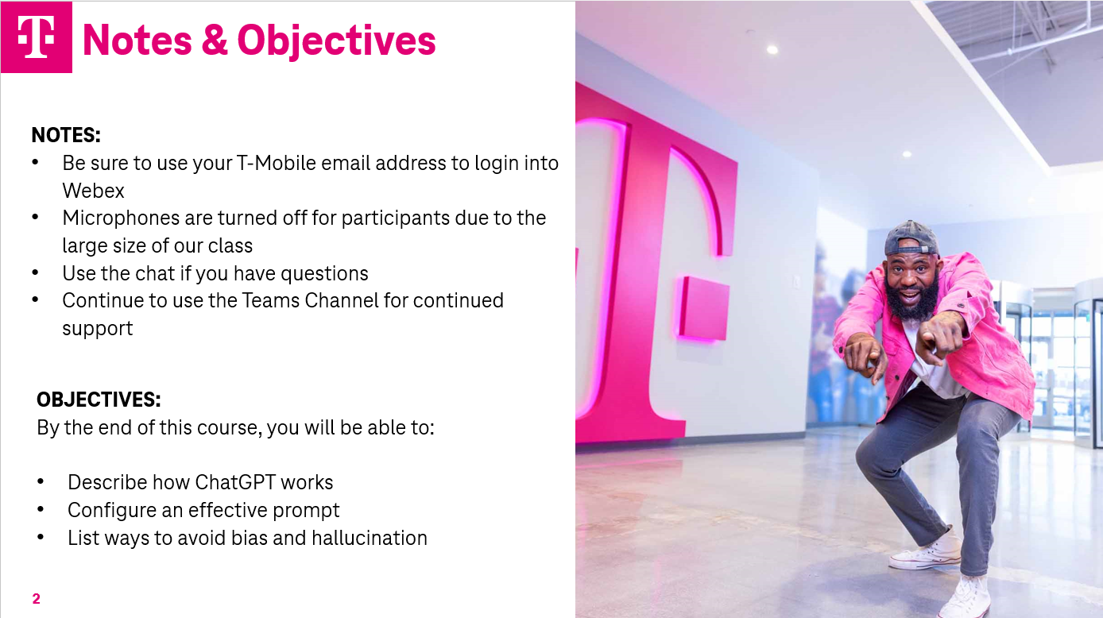 | [FAC NOTE: place the ChatGPT Teams link into the chat:  Enterprise GPT - General | General | Microsoft Teams  SAY:  As we get started today, I wanted to review some general notes about our session:  - As mentioned, please be sure that you are logged into this Webex session individually, using your T-Mobile email address.  - Microphones are turned off during the class because we have such a large group.  - As a result, place your questions into the chat and we will try our best to answer them before our time is done today.  - There is also a great resource for answers to questions, and pro-tips, and success examples in the ChatGPT Teams channel. I have dropped the link to it into the chat.  With that said, our objectives for today include:  - Describing how ChatGPT works;  - Configuring an effective prompt; and  - Strategies for avoiding bias and hallucinations.
 |  | 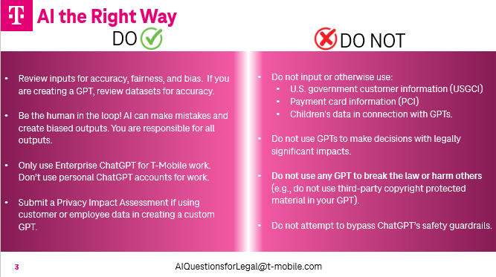 | SAY:  T-Mobile has a set of criteria to ensure that we are doing “AI the Right Way”:  Some key items on the “DO” side of things:  - Always maintain having a “human in the loop” by verifying outcomes and screening for bias.  - Use Enterprise ChatGPT for all your T-Mobile work. Never use a personal ChatGPT account for T-Mobile stuff.  Now, moving over to the “DO NOT” list, let’s put the key items into 2 categories:  First, Here’s WHAT NOT TO PUT INTO ChatGPT or reference as a dataset for your GPT:  - U.S. Government Customer Information;  - Payment Card Information; and  - Children’s Data.  Second, here are ACTIONS that you should NOT DO:  - Do not use GPTs to make decisions with legally significant impacts. This serves as a reminder that GPTs are to be used as a tool and not a decision maker. In short, we need to keep the human in the loop.  - You are responsible for reviewing and verifying the information used in the decision-making process;  - Do not use GPTs to break the law or harm others; and  - Do not attempt to bypass Enterprise ChatGPT’s safety guardrails.  We have a great resource and partner with the legal team supporting this pilot, so please reach out to them directly with any and all questions using the email address of “ AI Questions for Legal at T-Mobile.com”. I will put that email into our WebEx chat.
 | ACTION |  | [FAC NOTE: insert legal’s email address into WebEx chat]  AI Questions for Legal AIQuestionsforLegal@T-Mobile.com
 |  | 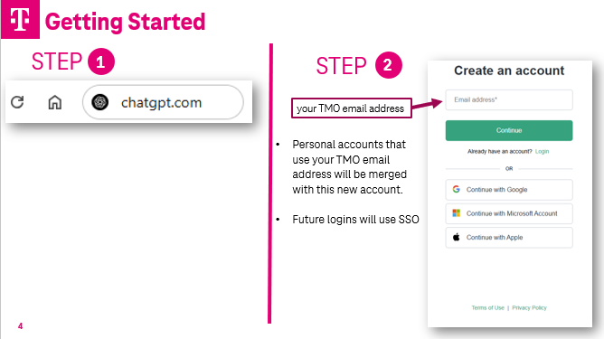 | SAY:  OK – We are nearly ready to jump in. But to do so, we want to make sure you have what you need. It’s not required that you have Enterprise ChatGPT up and running during this class, but you are welcome to use it during our activities.  Each of you should have gotten an invitation from Open AI.  If you have not logged into the T-Mobile Enterprise version of ChatGPT yet – follow these steps:  Step 1:  - In your browser, go to ‘chatgpt.com’  Step 2:  - Select ‘Sign Up’ and create a new account  - Use your work email address to login. NOTE: If you already have a personal ChatGPT account that uses your T-Mobile email address to login in – you will need to merge your personal account with this new Enterprise account.  Future logins will occur through Single Sign On and be seamless.
 | ACTION |  | [FAC note: insert links to files into the WebEx chat]  ZIP FOLDER (preferred)  https://t-mobile.bravais.com/s/1494/ChatGPT_101_Class_Hand_Outs  INDIVIDUAL FILES IF NEEDED:  https://tmobileusa-my.sharepoint.com/:i:/g/personal/craig_snyder42_t-mobile_com/EVQfC4yJVQhDnPOSUT3Ezw0B1rorAYFJxnjq1sYtfal5ig  https://t-mobile.bravais.com/s/1396/File_2_ChatGPT_101  https://t-mobile.bravais.com/s/1397/File_3_ChatGPT_101  https://t-mobile.bravais.com/s/1411/ChatGPT_101_PROMPTS  https://t-mobile.bravais.com/s/1398/ChatGPT_101_Activity_Guide  SAY:  We will be using several files today during our live demo.  I’m placing the links to those files into the WebEx chat now.  Please download them now and save them to an easily accessible spot for later. Doing this now will help keep us on track later as we start to go through them.  The files include a Word.doc that contains the prompts for the course. If you would like to follow along in your own ChatGPT session – you can copy/paste the prompts from the Word.doc  There is no requirement that you follow along. In fact, if you are new to ChatGPT, you may find it more productive to watch the demo unfold – and then use the prompts later to practice and explore.  The files also contain an Activity Guide that has many of the prompts and information from the course today. You can use that later to help with questions and to practice.
 | ACTION | 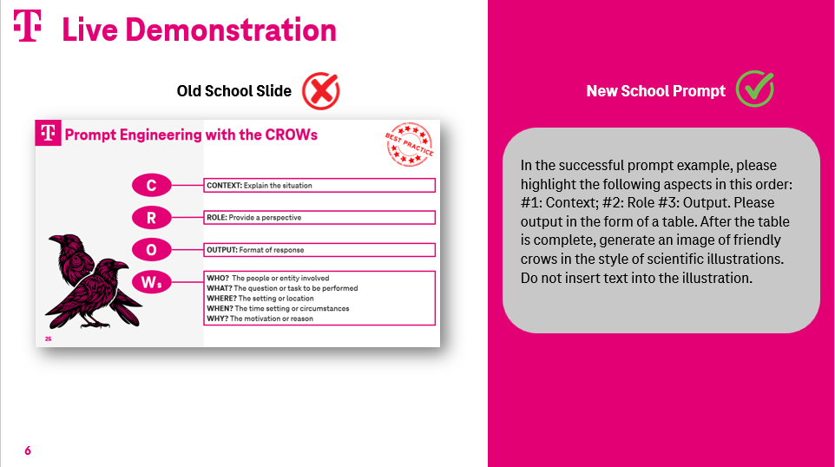 | SAY:  This new technology is changing the way we all work. For example, we are using a small amount of slides in this course.  Instead, I will mostly use ChatGPT to create all of the information you see on the screen. I’m doing it this way so you can get a real-world feel for how it behaves.  This can be a bit disorienting at first. It’s similar to wearing a new set of glasses – or playing games with a VR headset.  But here is a ProTip:  When you see a prompt being run and the text and images appearing on the screen as a response - think of that screen as being equivalent to a traditional PowerPoint slide.
 |  | 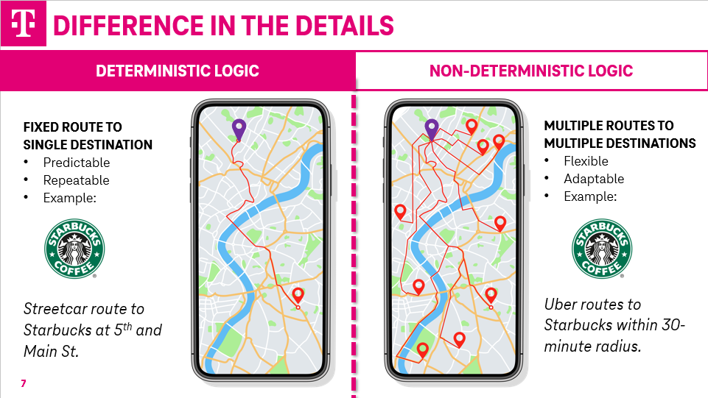 | SAY: Before we start with the live demo – I want to explain perhaps the biggest challenge of using this new technology:  It’s designed to interact with humans on a “human level” verses a “machine level”.  As a result, your ChatGPT responses today will vary from mine and most everyone else in this class. This is because of the different logic of ChatGPT.  Here is a comparison between what we are used to interacting with when it comes to technology.  Historically, technology has used what’s known as “Deterministic Logic”.  Deterministic logic is like following a set of fixed instructions— you get the same process and the same result every time.  The example on the left is someone stepping onto a streetcar to get to their destination – which happens to be the Starbucks on 5th and Main St.  The route is pre-determined and fixed. The rails of the streetcar will never move, and the rider doesn’t even have to tell the driver where they want to go.  In short – in the Deterministic world of tech – two things are always true: The destination is fixed and never going to change – and the way it gets to that destination is fixed and never going to change.  But ChatGPT does not use that kind of logic. Instead, it uses Non-Deterministic logic in order better engage and interact with us humans.  The example on the right is like ChatGPT and all other Large Language Models.  This person is at the same departure point as the one on the left, but instead of taking the streetcar, they decide to take aa taxi – and they tell the driver to find any Starbucks within a 30-minute drive.  As a result, at least three things are true:  1. The route they take can be one of many possibilities – and if they take that trip each day for a week or month or a year, they may never take the same route twice.  2. The Starbucks they end up at - may or may not - be the one at 5th and Main.  3. The taxi trip may take them to a Dunkin’ Donuts instead of a Starbucks by mistake.  As a result of this Non-Deterministic logic – you will probably have slightly different outcomes than what you’ll see on my screen – even though we are running the same prompts.  We will explore this later, once we get deeper into the course.  But for now – just know to expect it. It is – as they say – a feature and not a bug.
 | BEGIN SCREEN SHARING
 | ACTION  Course duration to this point:  20 min. |  | [FAC NOTE: show the T-Mobile logo in bottom left corner of ChatGPT screen ]  SAY:  There is a simple way to verify that you are using the T-Mobile Enterprise version.  You will see our logo in the bottom left corner of ChaptGPT. If you don’t see the logo, you are not using Enterprise GPT and your content will not be within the firewall of T-Mobile’s Cyber Security programs.
 | ACTION |  | [FAC NOTE: show an overview of the full screen to orient the learners to the user interface]  SAY:  Let’s take a quick tour of the full screen of Enterprise Chat GPT.  Starting at the top left of the screen – we see several icons.  The one on the left is a toggle than can hide/reveal the navigation panel. If you ever find yourself wondering where your past conversations went, this is mostly likely the thing that can answer that for you.
 | ACTION |  | [FACNote: navigate as directed in the script below]  SAY:  Moving downward beneath the icons – but still on the left side of the screen in the Navigation Panel are several Menu Items. These items act like buttons, although they don’t really look like buttons.  - At the top of the Menu Items is the magnifying glass – used to start a “New Chat”.  - Under that is the magnifying glass for “Searching Chats”  - Then there is the “Library”, which contains past images that have been created so you can re-use them.  - Under that is an icon for “Codex” – which we are not going to worry about because it’s turned off in our Enterprise version.  - Next up is the “GPTs” icon  Note: Some of you may see other Menu Items between “ChatGPT” and “Explore GPTs”. If so, that just means you’ve made some of your own already, or have used others – and they appear as a shortcut.  We are going to focus on “GPT’s” – so I’ll go ahead and click into that so we can all see it.
 | ACTION |  | [FACNote: point out the areas mentioned in the script below]  SAY:  The GPT main page contains many GPTs that others at T-Mobile have created.  These are called Custom GPTs because they leverage the power of ChatGPT but focus that power into performing specific tasks in a reliable and repeatable way. This is a fun place to explore and you will most likely find one, or many, that can be helpful to you.  Note: You will also see GPTs in there that are greyed out. Those are 3rd party GPTs that are not available to us because of our firewall and cyber security guardrails
 | PROMPT 1  ACTION | What does GPT mean? | [FAC Note: return to ChatGPT using the navigation menu on the left and within the chatbox, enter prompt 1.]  SAY: This is prompt number 1.  It seems we have used the term “GPT” a lot already today. So before we go too much further – let’s define it.  This prompt says simply enough “What does GPT mean”?
 | ACTION |  | SAY: [FAC Note: Summarize the response and reinforce how it’s built to interact with humans.]
 | ACTION |  | [FACNote: Point out the Projects Folder and click the “plus” sign to add a new project. Name it whatever you want and point out the specific areas of the Project Folder as described in the script below.]  SAY:  Our next Menu Item is called “Projects”. This is nifty tool to use for multiple reasons.  Let me show you how it works. You should see a “plus” sign next to the name “Projects”. If you do not see it – hover your mouse over the name – or use the tab key to activate it.  The first thing it asks for is a name. So give it a name of your choosing. I’m going to call mine “Communications”. Then select the “Create Project” button.  And starting from the top down, notice the familiar chatbox.  But directly under the chatbox are some unassuming, yet powerful containers:  - Place to hold files  - Place to store instructions  The reason these are so powerful is that anything you place in these storage areas can be used by every ChatGPT conversation you have inside the folder.  Here is a simple example:  One frequent user of this tool explained that they use it this way.  The File section contains a Word document of all the people she regularly communicates with. Some of those people are her leadership team, while others report directly to her.  Next to their names is a brief description of the communication style they prefer. Some like short and direct information delivered through bullet points – while others want more details and backstory. Some a strict business, while others may like things more casual.  The Instruction section says to match the name of the recipient of the communication to their preferred style – and write the communication accordingly.  So they write a draft of the communication into the chatbox, which includes the recipient’s name – and it generates a custom communication that can be copied/pasted into email or such.  Plus, the beauty of a Project Folder is that it keeps all those chats in one place, so you can always go back and track them down if needed.
 |  | 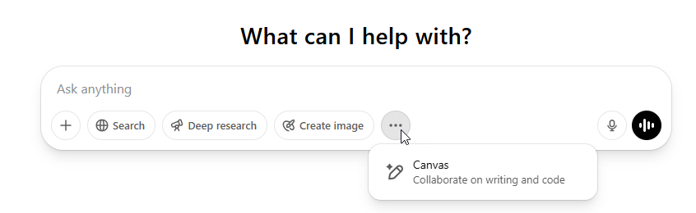 | SAY:  OK – that completes our tour of the Navigation Panel – now let’s turn our attention to the big ChatBox.  Go up to the top of your Navigation Panel and select the icon for starting a New Chat.  Under the friendly title of “What can I help you with?” is our friend the ChatBox. This is where most of the action takes place when you are entering prompts.  By the way – a “prompt” is just a fancy way of saying instructions, or questions, or directions.  And when ChatGPT replies to that prompt, we call that a “response”.
 |  | 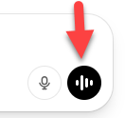 | SAY:  In addition to having an open space to type a prompt, there is another way you can enter a prompt – and that is through the Voice Mode icon.  Note: you may not see this icon if you are using a different browser than Chrome or Edge on your desktop.
 |  | 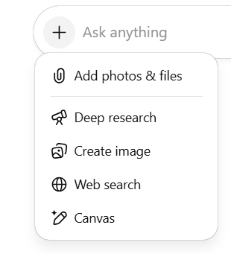 | SAY:  As we move left from that icon, you will see a “plus” sign (+). When you click on it, you will see icons for:  These include:  Uploading Files  Deep Research – is specially designed to take a complex prompt – and spend lots of time and analysis to work on it’s response. It can often take 10 minutes to 1 hour or more to build a response. I do not suggest you use this unless you have something really big that you are working on.  Image Creator – which uses DALL-E, OpenAI’s amazing graphics tool.  Web Search. This is great tool to use if you specifically need the most up-to-date information on a topic – since ChatGPT defaults to whatever was current when it was last trained.  For example, if you wanted to know about T-Mobiles Financial Reports in 2025, you would want to ensure ChatGPT is pulling it from the web – since it was last trained in June of 2024.  ProTip: You can always ask ChatGPT when it was last trained.  Canvas – which is document editor that we will use later in this course.  There are two things to know about these shortcuts:  - They may come and go – be added to – or taken away, as OpenAI continues to expand and refine it’s tools.  - You can get to all of these tools by asking for them in the prompt. And often ChatGPT will just open them automatically if it thinks it would be useful to you.
SAY:
So that concludes our tour of the Main Page.
Now let’s put that ChatBox to use!

 | TRANSITION > Intro to idea of ChatGPT as “Thought Partner”
 | PROMPT 2 | Would you make a good Thought Partner for me? | [FAC Notes: Insert prompt #2]  SAY: I’m entering prompt #2  OK – let’s start our first of many conversations with Chat GPT.  A conversation with ChatGPT can best be described as a conversation with a thought partner.  Rather than simply delivering answers or performing tasks, ChatGPT engages in an interactive process—helping you clarify your thinking, uncover blind spots, and refine your approach.  This notion of interacting with ChatGPT as a “Thought Partner” is a key take-home message for today.  We encourage you to embrace this new technology as you integrate it into your everyday work. Allow yourself to:  - Get curious;  - Ask questions;  - Jump into topics; and  - Develop new skills.
SAY:
As I mentioned, you can follow along in your own ChatGPT session if you like – but it’s not required.

I’ll describe the prompts as I go along.
If you miss some, or get confused – don’t worry- the prompts will be available in the Activity Guide for you to refer back to.

SAY:
Before we move forward, give me an emoji if you used this prompt but got a different response than I did.

[pause for participants]

Aha! Just as expected. Remember we introduced how Non-deterministic logic used by ChatGPT does not follow a fixed route to a fixed destination? This is what it looks like in action.

But please, try not to let it throw you off – it’s a new way of working – and will take some time – but it does have it’s advantages.

We’ll learn about it in a few minutes, but I wanted to make sure to call it out now – so you all don’t feel like you’re having vision problems or did something wrong.

 | TRANSITION > Types of Prompts
 | ACTION | 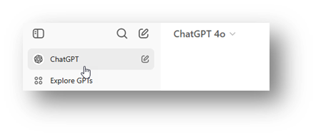 | [FAC NOTE: Select new chat icon from the navigation menu]  SAY:  Since I’m working on a new topic, I’m going to make sure to leave my current chat session, and start a completely new one – in order to avoid one conversation influencing the other.  Think of this need to start new conversations as “Chat Hygiene” – where you are avoiding “cross-contamination” of information from one conversation getting into the other.
 | ACTION | 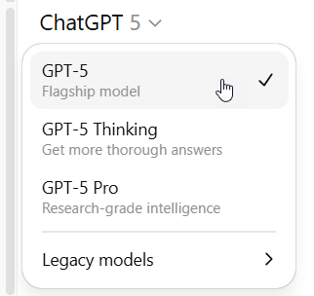 | [FAC: highlight the various models by clicking into the tab]  SAY:  Let’s start with a question using text. I’ll use the default GPT model. Think of it as the “Regular” one – or another way of saying it is there’s nothing extra-special about it.  It’s a good all-purpose model that is ideal for most non-specialized types of tasks.  If we give it something extra complicated to work on while we are using the regular model, it will automatically switch to using a “thinking” model – which means it will think harder and much longer.
 | PROMPT  3 | What is 5G? | [FAC NOTE: Enter prompt 3]  SAY: I’m entering prompt #3 which is asking it: “What is 5G?”  And you can see that ChatGPT has provided us with an answer very quickly. It’s also an answer that has many different subtopics within it.
 | PROMPT  4 | Can you please compare 5G speeds? | [FAC NOTE: Enter prompt 4]  SAY: I’m using prompt 4  Let’s explore one of those subtopics. I’m going to ask it to compare 5G speeds.
 |  | 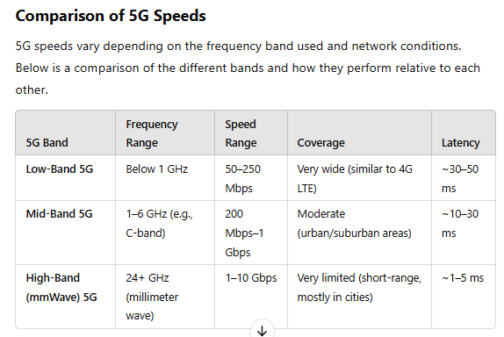 | SAY:  The response is a comparison of 5G bands, showing the ranges of speed and latency times.  This exchange is an example of Text-to-Text prompting. Meaning, I used text for my prompt, and I received text back as a response.
 | PROMPT  5 | Show the comparison by using a graph. | [FAC NOTE: Enter prompt 5]  SAY: This is prompt 5.  Let’s suppose I want to leverage that text-based response into something more descriptive through the use of visuals. All I need to do is ask.  Here I’m entering a prompt asking it to show this comparison through a graph.
 |  | 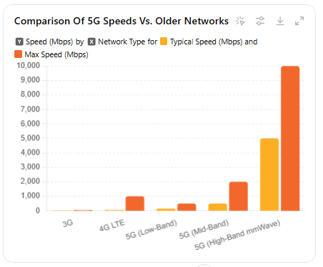 | SAY:  And the result I get back is a chart created by DALL-E, an image creator based on text inputs  This is an example of Text -to- Image prompt.
 | ACTION  Change the graph colors. | 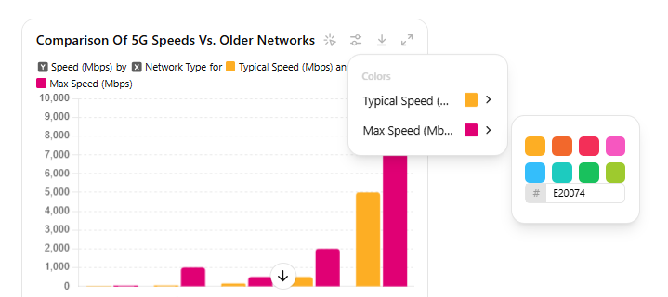 | [FAC NOTE: Change graph colors]  SAY:  And yes, the colors can be edited to match our brand guidelines.  You can edit an image using the settings function:  Click into the sliders at the top of the image and select a color swatch or enter a HEX code which denotes a specific color.
 | PROMPT 6 | Change the colors of the chart to T-Mobile brand. | [FAC NOTE: Enter prompt 6]  SAY: Using prompt 6, - you can change it using prompts. Here I’m telling it to use T-Mobile colors.
 | ** PAUSE** SECTION SUMMARY ** PAUSE**
 | 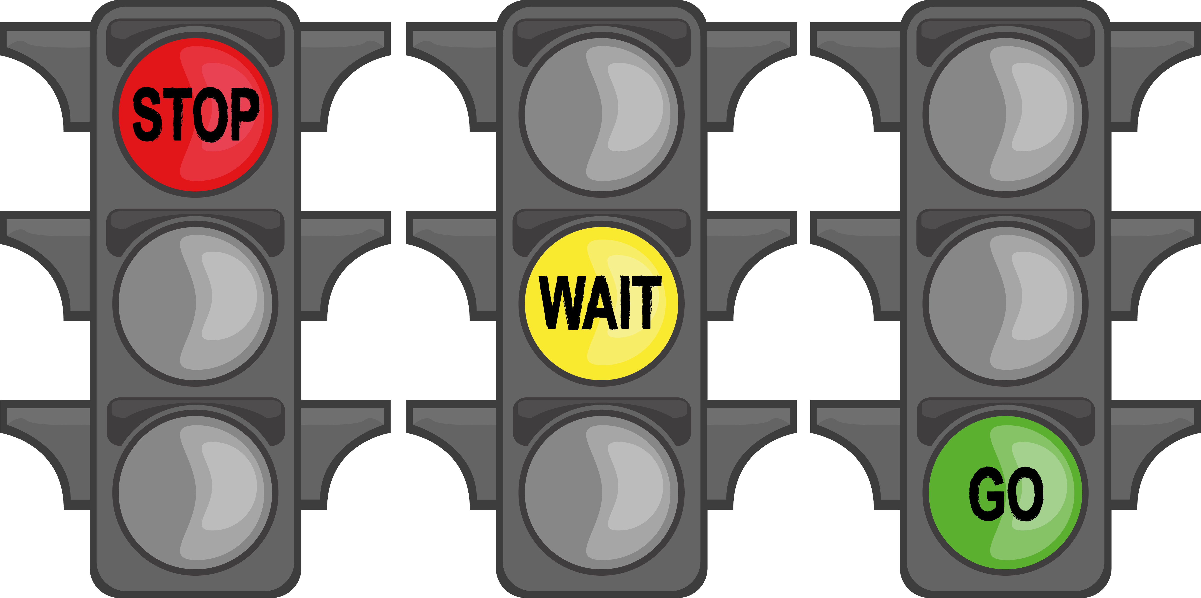
 | ACTION  Scroll up to the original prompt and then scroll down while talking.  Course duration to this point:  40 min. |  | [FAC NOTE: scroll through the screen]  SAY:  So let’s pause here for a minute to review how we got to this lovely graph:  - First, I asked what 5G was.  - In order to answer that question, it did some processing behind the scenes.  - It then formed a response, which in this case was wide-ranging information, featuring several subtopics.  - I then decided to explore one of those subtopics further, by asking it to compare 5G speeds.  - Then it worked on that prompt behind the scenes again and provided the comparison using text and numbers in a table format.  - While the table was informative, it was not telling a powerful story on it’s own, so I asked ChatGPT to output the information in the form of a graph.  - So it went back and used the data to form a graph using the image creation tool called DALL-E.
SAY:
So essentially there is a process flow:
- First, there is an input or prompt – which in this case was text in the form of a prompt.
- Then ChatGPT processes the input in the background.
- Then it provides an output or response based on the criteria we gave it in the prompt.
 | TRANSITION > Deterministic vs Non-deterministic logic
SAY:
Now we get a chance to look closer at the Non-deterministic logic involved with ChatGPT and all Large Language Models.

If you recall – this is the scenario we illustrated at the start of class – where we compared a person taking a streetcar to their favorite Starbucks – against person that took a taxi to any Starbucks within a 30 minute drive.

ChatGPT – and all Large Language Models - uses a Non-Deterministic logic. Which simply means that when it forms a response – it’s NOT following a fixed or rigid path that will lead it to the same result every single time (i.e. the streetcar to the Starbucks on 5th and Main St.)

 | ACTION |  | [FAC NOTE: go to navigation panel and click on new chat icon]
 | PROMPT A | Create a side-by-side comparison table of Deterministic Logic and Non-Deterministic Logic. Use clear, concise language suitable for a high school or early college-level audience. Include the following columns:  - Feature  - Deterministic Logic  - Non-Deterministic Logic  Include comparisons in terms of:  - Definition  - Outcome  - Decision Making  - Speed (Theoretical)  - Real-Life Example  - Programming Analogy  Format it in a clean, easy-to-read table. Use a warm and approachable tone, like a friendly professor explaining concepts in class. | [FAC NOTE: Enter prompt A]  SAY: This is prompt letter “A”, which is the first of several optional prompts. I’m using these to help reinforce the learnings, since we are not using PowerPoint slides. You do not have to follow along.  So, what’s the big deal?  This difference between deterministic and non-deterministic logic really changes how we think about technology.  With deterministic logic, outcomes are predictable and repeatable. That’s great for some uses.  But non-deterministic logic brings something new to the table: flexibility. It allows a system to make decisions, explore different paths, and even adapt along the way.  This is exactly what makes AI feel more human—it’s not just following instructions, it’s responding to the world in real time.
 | PROMPT B | Compare deterministic and non-deterministic logic using a real-world analogy involving two well-known musicians who play the same instrument. Use one musician from a structured music style (like classical) and one from an improvisational style (like jazz). Present the comparison in a table format with the following columns:  - Concept  - Music Style  - Real-Life Musician  - Performance Approach  - Logic Connection  Keep the tone friendly and clear, at about a 10th-grade reading level. Make it easy to use in a learning environment. | [FAC NOTE: Enter prompt B]  SAY: This is optional prompt letter B.  To help remember this type of computer logic, let’s try a real-world comparison:  Deterministic logic is like a classical musician. The artist follows an established route – using a written composition - plays essentially the same song, the same way, each performance.  Non-deterministic logic is like a jazz musician. The artist creates a new route – using improvisation – giving expansive variations of the same song, each performance.
 | ** PAUSE ** Summary ** PAUSE**
 | Course duration to this point:  45 min. |  | SAY:  All of this is to illustrate that you need to maintain being the human in the loop.  Regardless if the output is an:  - Image;  - Text;  - Numerical calculation; or  - Code.  ChatGPT is going to occasionally get it wrong – and you should be expecting it.
SAY:
All that said, there are some ways to greatly improve the likelihood that your prompts will generate an output that is aligned with what you were intending.

And the way to make better prompts is through “Prompt Engineering”.

 | TRANSITION > Introduction to Prompt Engineering
 | ACTION |  | [FAC NOTE: go to navigation panel and click on new chat icon]
 | PROMPT  7 | You are a classroom teacher, and you need to explain “Prompt Engineering” to a 5th Grader. Provide 2 examples. Ensure there is a specific role in the example. The first example should be too vague and too general to be successful. The second example should be detailed enough to be a good example of prompt engineering. | [ FAC NOTE: Enter prompt 7 ]  SAY: This is prompt 7.  These next prompts are going to generate some material for me to work with.  While the term “Prompt Engineering” can be intimidating, please don’t let it scare you. Let’s see how ChatGPT describes it when I use another one of my favorite prompts:  “Explain it to a 5th grader.”
 |  | 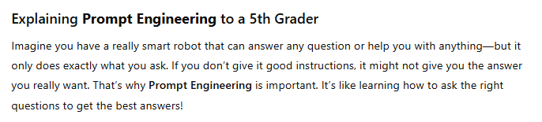 | SAY:  [FAC NOTE: Read the explanation aloud]
 |  | 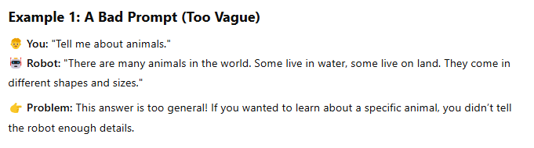 | SAY:  [FAC NOTE: Summarize Example 1 aloud]
 |  | 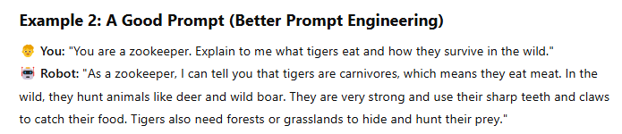 | SAY:  [FAC NOTE: Summarize Example 2 aloud]
SAY:
Although your response to the “5th grader” prompt may have been a different version of what I got – none the less – it offers some important clues related to best practices for Prompt Engineering.

 | PROMPT  8 | Create a table that contains the successful prompt example. Label column #1 “Context”, Column #2 “Role”, and Column#3 “Output”. | [FAC NOTE: Enter Prompt 8]  SAY: This is prompt 8.  The best practices for Prompt Engineering include having these three key items:  - Context;  - Role; and  - Output  Or as we like to think of them – the “CROWs”!
 | ACTION |  | [FAC NOTE: read out the response as it relates to the fields below]  SAY:  In the successful example:  - Context is the section of the prompt where ________  - Role is the part which ________  - Output refers to the __________
 | PROMPT  9 | Please provide a brief and concise description of the “5Ws” method and how it can be used to support the need for Context, Role, and Output. | [FAC NOTE: Enter prompt 9]  SAY: This is prompt 9.  So we have the “C” and the “R” and the “O” of our CROWs, but what of the “Ws”?  The W’s refer to:  - Who  - What  - Where  - When  - Why  There is any easy way to ensure you’re you have the 5W’s covered. Simply ask ChatGPT to interview you to gain the knowledge.
 | ** PAUSE** SECTION SUMMARY ** PAUSE**
Course duration to this point:  55 min. |  |  | SAY:  Now – Before I go deeper into using the CROWs structure, I just want to review how we got here.  We started by describing how “hallucinations” are a result of using Non-deterministic logic. It’s not that ChatGPT does not know the answers – but instead – it gets the answers wrong at times because it’s trying to use a system that works well with humans.  In order to avoid hallucinations as much as possible, we use “Prompt Engineering” – which is a way of structuring prompts with clarity and direction.  The framework we endorse for Prompt Engineering is called “CROWs”, which stands for:  Context  Role  Output  W’s:  - Who  - What  - Where  - When  - Why  Note: Tell the GPT to interview you if it needs answers to the 5Ws.
 | TRANSITION > Putting CROWs Into Action
SAY:
Let’s take a few minutes to test drive some prompts using the CROWs format. If you have the Enterprise version of ChatGPT up and running, please customize this activity to fit your specific situation.

If you don’t have a ChatGPT session going, you get the entertainment value of watching me do it.

 | ACTION |  | [FAC NOTE: go to navigation panel and click on new chat icon]  SAY: Since this conversation will be a new topic, please practice good Chat Hygiene by starting a brand-new chat conversation.
 | PROMPT 10 | Your first name:  Your job title:  “In need help with Time Management”  - How can I make up for the work I’m missing because I’m taking this class?” | [FAC NOTE: Enter prompt 10 one line at a time – as having a discussion with ChatGPT – narrate as you enter the text]  SAY: This is prompt 10 – but I would like you to enter them as single items, one-at-a-time. Much like a conversation with someone.  We will start a conversation by writing in the chat box the following items:  - First thing to enter is your name.  - After that, enter your job title.  - Then, write the statement: “I need help with Time Management”  - Followed by the question: “How can I make up for the work I’m missing because I’m taking a class?”
SAY:
This is my gift to you if you have anxiety about getting your work done while having to take these ChatGPT classes.

 | PROMPT 11 | Tell me more about #2. | [FAC NOTE: Enter prompt 11]  SAY: This is prompt 11.  Let’s go one step further with this conversation. Select one of the items from the response and ask it to tell you more about it. You can reference the item by using the number next to it.  I want to learn more about number 2.
 | SECTION SUMMARY
 | PROMPT C | Using the style of a 1980's dot-matrix printer, create the shape of a funnel by only using these letters: C, R, O, W. | [FAC NOTE: Enter prompt C – No need to start a new chat]  SAY: This prompt is creating an image for us to reference. You don’t need to run it.  If we step back and look at this quick chat we had about Time Management, you will notice that it unfolded over time. We have all the CROW elements, but it was a process of narrowing and getting more specific – like using a funnel approach.
SAY:
This is much like human conversations - where – to have a more effective outcome – we discuss - ask questions of each other – and following wherever the conversation takes us, until we get to the level of detail and answer that we need.

 | ** PAUSE** SUMMARY ** PAUSE **
 | Course duration to this point:  60 min. |  | [FAC NOTE: point to navigation panel]  SAY:  OK – before we move on from this section on Prompt Engineering– I just want to revisit how we got here and why it matters.  We started out by stating that the “Non-deterministic” logic found within ChatGPT and all Large Language Models is built that way in order for us humans to interact with and leverage the ability to use all that it has to offer – without needing to learn how to code or have specialized knowledge.  However, because of this logic, ChatGPT can hallucinate and get things wrong.  In addition to being the “Human in the Loop” to spot check it and ask it how or why it came up with the answer it did – we can help it provide more accurate responses by using a CROWs format – giving it lots of good detail in the prompt so it has less room to hallucinate.
 | TRANSITION > Inputs for Prompts
 | ACTION |  | [FAC NOTE: go to navigation panel and click on new chat icon]
SAY:
I want to make sure I cover another aspect of great prompts – which is – the ability to leverage a variety of types of inputs.

Throughout our time today we’ve used prompts that use text as an input – meaning we wrote out our prompts in the chat box. And we asked for outputs in the form of text and images.

But let’s expand on those by introducing some other options.
 | PROMPT 12 | Please tell me all the different types of input you can use to respond to a prompt. | [FAC NOTE: Enter prompt 12]  SAY: This is prompt 12.  If you are wondering what other type of inputs ChatGPT can accept – just ask it!  Here I’m asking it to describe the types of input it can use to respond to a prompt.
 | ACTION | Scroll through the list of items on screen. | [FAC NOTE: scroll through screen]  SAY:  And it’s letting me know that it can use:  - Text ( typed in, spoken via voice mode, copy/paste);  - Images (.jpg, .png, .gif, .tif and more);  - Files such as:  - PDF;  - Word (.docx);  - Excel (.csv preferred);  - PowerPoint; and  - Coding languages (ask it for more details)
 | TRANSITION > ACTIVITY USING FILES
 | ACTION |  | [FAC NOTE: go to navigation panel and click on new chat icon]  SAY:  Let’s put some of these inputs into action. Please start a brand new chat window.
 | ACTION |  | [FAC Note: insert links to file downloads into WebEx chat]  ZIP FOLDER (PREFERRED):  https://tmobileusa-my.sharepoint.com/:i:/g/personal/craig_snyder42_t-mobile_com/EVQfC4yJVQhDnPOSUT3Ezw0B1rorAYFJxnjq1sYtfal5ig  INDIVIDUAL FILES:  https://t-mobile.bravais.com/s/1396/File_2_ChatGPT_101  https://t-mobile.bravais.com/s/1397/File_3_ChatGPT_101  https://t-mobile.bravais.com/s/1411/ChatGPT_101_PROMPTS  https://t-mobile.bravais.com/s/1398/ChatGPT_101_Activity_Guide  SAY:  Now – remember those links to file downloads I gave you at the start? We will now start using them.  If you did not get a chance to download them yet – I’m placing the links into the WebEx chat again.  Note: these are the same files I sent at the start – so if you already downloaded them, there is no need to do it again.
 | ACTION |  | [FAC NOTE: Drag File 1 Image into your chat box]  SAY: We are going to start with File 1 – an image of a white board. But again – no worries if you decide not to follow along – it’s not required.  Using the image of the white board – which is File 1 - copy/paste it – or - click and drag it - into your ChatGPT.
 | PROMPT 13 | Please review this image and summarize. | [FAC NOTE: Enter prompt 13]  SAY: This is prompt 13.  And just like we did with our text based prompts, we are going to start in a very general way – and narrow things down to specific through conversation.  So to begin with, my prompt is simply going to say:  “Please review this image and summarize”
SAY: This is a Best Practice when you use any type of input files, such as images, documents, spreadsheets, etc. because it forces ChatGPT to become familiar with all the contents first, before looking for specific details.

Now that it told me what was on that whiteboard, I can dive in further using the CROWs method and actually start working on some of these items.

For example, I could ask it to develop a Project Plan, or establish Priority Levels, or ask for clarity on an item.
 | PROMPT 14 | Please create a list of Action Items and rank them in order of priority. | [FAC NOTE: Enter prompt 14]  SAY: This is prompt 14.  Here I’m going to ask it create a list of Action Items, ranked in order of priority.  OK – that was a fun way to leverage and utilize the work product that came out of the meeting in the conference room.
 | ACTION |  | [FAC NOTE: go to navigation panel and click on new chat icon]  SAY:  Let’s try a different type of input. Remember, we need to practice good Chat Hygiene in order ensure information from the last chat does not seep into what we’re doing next.
 | ACTION |  | [FAC NOTE: Place File 2 and 3 into your ChatGPT chat box]  SAY:  Now let’s use Files 2 and 3. They are both .pdf of T-Mobile’s Annual Report. One is from 2021 and the other is from 2024.  Insert both of them into your fresh chat box in ChatGPT like you did with the image.
 | ACTION  PROMPT  15 | Review and summarize these files. | [FAC NOTE: Click on the files within the chatbox to open a preview of the pdfs so learners can see what the files contain. Enter prompt 15]  SAY: This is prompt 15.  If you are unsure about what your files contain, you can click on them within the Chatbox before submitting your prompt to verify you have the correct files.  As we learned before, the first prompt we want to use when first working with files is to have ChatGPT review and summarize them – to force the technology to become familiar with all of the content.  As such, I’m entering a prompt that simply says “Review and summarize these files.”
SAY:
While it’s busy reviewing – keep in mind that each of these files is around 200 pages.

 | ACTION  Scroll through response |  | [FAC NOTE: Scroll through response while narrating]  SAY: I’ll read the section headers while we see how it compared the 2021 numbers with the 2024 numbers.
 | PROMPT  16 | Do you see anything significant regarding Customer Churn? | [FAC NOTE: Enter prompt 16]  SAY: This is prompt 16.  So there are many ways we can further explore these findings – depending on what areas we wanted to focus on.  I’m going to choose one specific topic, since it involves all of us at T-Mobile, no matter our role.  Our SLT often reminds us that Customer Churn involves everyone within the company, not just those on the frontline helping customers. So lets explore Customer Churn for a minute.  Since I’m not on the frontlines, I’m not exactly sure what to even ask it. And that is just fine. Remember, the power of ChatGPT is it’s ability to respond through discussion, and not require specific commands written in specific ways.  So I’m simply entering a prompt that says “Do you see anything significant regarding “Customer Churn”?
SAY:
It responded with some insights – comparing Churn rate between 2021 and 2024. Most notably is the fact that we improved our Churn rate by 12 basis points over the three years.

Well done everyone!
 | PROMPT  17  ACTION | I’m a __(job title)__ within the _________ workgroup. How can I improve churn? | [FAC NOTE: Enter prompt 17 & CUSTOMIZE using your own role & workgroup, or use this example: “Program Manager / Marketing”  SAY: This is prompt 17.  Now I’d like you to enter another prompt in this conversation.  Please continue the chat by telling it what your job title is, and which workgroup you currently work in. Follow that with the simple question: “How can I improve churn?”
SAY:
You should see some relevant suggestions and guidance on ways to make an impact on churn with the work you do.

 | ** PAUSE** SUMMARY ** PAUSE**
Course duration to this point:  1hr 10 min. |  |  | SAY:  OK – before move on – I just want to take a minute to remember how we got here.  We started by exploring how different types of inputs, such as files, photographs, and such can be included into a prompt.  We first reviewed the photo from a conference room white-board to help us generate actionable information from the summary.  We then used two files that were T-Mobile’s financial statements to evaluate out customer churn.  And we customized potential action items for improving churn by having ChatGPT generate ideas and tasks based on our role and business group.
 | TRANSITION > Editing in Canvas
 | PROMPT  18 | Create a strategy memo in Canvas that I can share with my workgroup. | [FAC NOTE: Enter prompt 18 ]  SAY: This is prompt 18.  I’m going to show you another awesome feature of ChatGPT – the editing app “Canvas” is integrated into ChatGPT.  Please enter a new prompt in the conversation that says: “Create a strategy memo in Canvas that I can share with my workgroup”.
 | ACTION |  | [FAC NOTE: point out the screen areas ]  SAY:  So it pulled information from throughout our conversation so far, and created this strategy memo for me to share with my group.  As you can see, our existing conversation has moved over to the left, and the Canvas editing screen has taken center stage.  Let me say it again in case you missed it - the way to launch Canvas within ChatGPT is to tell it to use Canvas in the prompt.
 | ACTION | 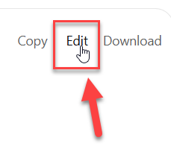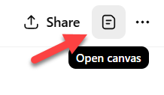  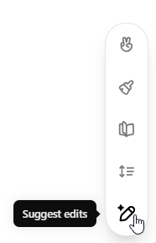 | [FAC NOTE: Select “edit” at the top of the memo to open it within Canvas. Select text in the “Objective” paragraph, then click on pencil icon to show tools]  SAY:  Top open the memo in Canvas, you can either select the “edit” button in the top right corner of the memo – or – select the document icon in the top right corner of the screen – if you hover over it the label says “open canvas”  The primary way to edit within Canvas is to highlight the text you would like to focus on, and then select the pencil icon in the bottom right screen. When you hover over it, several tools will appear.
 | ACTION |  | [FAC NOTE: select the “Adjust Length” tool and demonstrate different lengths. NOTE: Click + Hold + Slide to make adjustments.]  SAY:  One of my favorite tools is ‘Adjust Length’. It provides a dynamic scale for you to increase or decrease the content.
 | ACTION |  | [FAC NOTE: select the “Reading” tool and demonstrate different lengths. NOTE: Click + Hold + Slide to make adjustments]  SAY:  In a similar way, there is also a scale for complexity. I can increase the reading comprehension level to be something in line with Graduate Students – or - I can decrease it all the way down to Grade School level.  For our purposes today, I’ll set it to “College Level”.
 | ACTION | 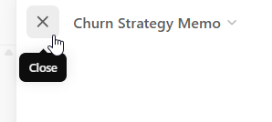 | [FAC NOTE: select the X icon next to the file name within Canvas]  SAY:  Once you have your edits complete, you can close Canvas and it will bring the chat box back to center screen.
 | ACTION  Course duration to this point:  1 hr. 20 min. |  | [FAC NOTE: select “download” icon from upper right corner in Canvas]  SAY:  In order to finish up with the memo, we can either copy/paste it into an email or a larger document. Or, we can download it in Word or PDF format by selecting the download icon in the upper right corner of Canvas.
 | ** PAUSE ** SUMMARY ** PAUSE**
SAY:

So let’s pause again to review what we just covered.

We had ChatGPT take the work that it did with crunching the financial reports and churn data, and had it create a “Strategy Memo” that I could share with my workgroup.

In order to edit that Strategy Memo, we used Canvas – which has number of effective edit tools which you can get to by selecting the “pencil” icon.

You can get to Canvas by selecting it within the ChatBox or just tell ChatGPT you want to use it.

 | TRANSITION > Describe Custom Profile
SAY:
Well, I have one last feature to show you today.

If you think back to what we covered today, we spent a lot of time on how this new technology works, and some of the framework you can use to make it more effective – such as providing the CROWs”

- Context
- Role
- Output
and
- The Five W’s

Well – now I want to show you how you can enter much of that information as default settings, so that ChatGPT is always aware of them and incorporates them into the responses it gives you.
 | ACTION | 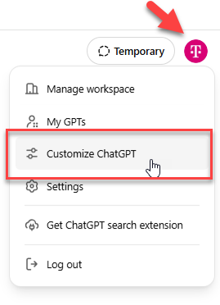 | [FAC NOTE: show how to navigate to the “Customize ChatGPT” interface]  SAY:  Getting to this feature involves going to a panel that allows you to customize your ChatGPT conversations.  You get to that panel by clicking on the T logo in the bottom left corner of your screen.  Then select “Customize ChatGPT”.
 | ACTION | 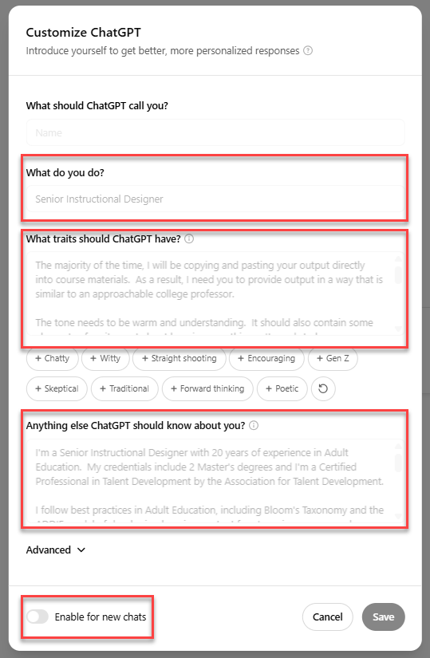 | [FAC NOTE: show the various parts of the custom profile]  SAY: In this panel, you can set up a custom profile that will always be used by ChatGPT when it responds to you. It’s a way to hardwire some of the CROW’s we’ve been talking about within Prompt Engineering.  You will see sections for:  - Your role  - What traits you would like ChatGPT to have when responding. This includes some suggested items that you can click to add – such as being “encouraging” or “witty” or “skeptical”.  - An open text field to let ChatGPT know additional information about you – which would influence how it responds.  Some suggestions you may want to consider adding to your Custom Profile include:  - Career experience and focus areas  - Credentials  - Professional organizations and other sources for best practices you may follow in your work.  - Specific formats or criteria or methods you may use in your work.  - Format for the responses that it provides you – for example, do you prefer short and concise utilizing bullet points? Or, do you prefer a 3 paragraph format that you can edit down if needed.  - The level of reading comprehension you prefer, for example, T-Mobile policies are written at a 10-grade reading comprehension level.  In general, making this as robust as possible, aligned with how you usually do your work, will make this tool much more productive for you.  Importantly, there is a way to turn your profile off when needed – so it does not interfere or conflict with a different role or scenario you may be using when writing a prompt.  I encourage you take some time between now and when you take the 102 class to review this custom profile panel and fill it in with details about you and the work you do, along with any preferences.  Another way of saying it - filling out your Custom Profile is your homework assignment between now and when you take the 102 class.  Trust me – it will improve not only how you work with ChatGPT, but also the quality of responses that ChatGPT provides.
 | TRANSITION > Closing Section
 | PROMPT D | Please show me how to say Thank You in American Sign Language. Then, generate a comprehensive list of the phrase "Thank You" translated into every known language. Present the results in a two-column table:  - Column 1: The translated phrase for "Thank You" written in the original script (e.g., "Gracias", "ありがとう", "Merci", etc.).  - Column 2: The name of the language the phrase belongs to (e.g., Spanish, Japanese, French).  Include as many languages as possible and sort the table alphabetically by language name. | [FAC NOTE: Enter prompt F]  SAY:  So with that, I’ll enter one last visual prompt to help me say thank you for your patience today as we explored this exciting world of ChatGPT.  We will carry all this knowledge forward into our 102 course.  I encourage you to spend the time between this class and the next class using ChatGPT on a daily basis.  The more you use it, the faster you will begin to integrate it into your workflow.
 | END SCREEN SHARING > RETURN TO LAST SLIDE IN POWER POINT
 | Course duration to this point:  1 hr. 25 min. |  | SAY:  We have some time for Q&A now. If you did not get your questions answered in chat, please enter them again and I will address as many of them as I can.  As a reminder, the dedicated Teams channel is also a great place to ask questions and learn from the pro’s.
 | ACTION |  | [FAC NOTE: insert Teams channel link into chat]  Enterprise GPT - General | Enterprise GPT - General Support | Microsoft Teams  [FAC NOTE: insert MtM link into chat]
SAY:
I’ve also posted a link to our survey for this course. Please take a few minutes to let us know how this course went for you. We use your feedback to inform revisions – since we believe in the power of a continuous improvement process.

 | ACTION |  | [FAC NOTE: The moderator will direct specific questions from the chat in a direct message to you within WebEx. Please use the following criteria and responses:  - Questions regarding content from the course = Directly answer them for the benefit of all.  - Other questions = Ask them to post it in the Teams Channel, where Subject Matter Experts can help them.

